

**[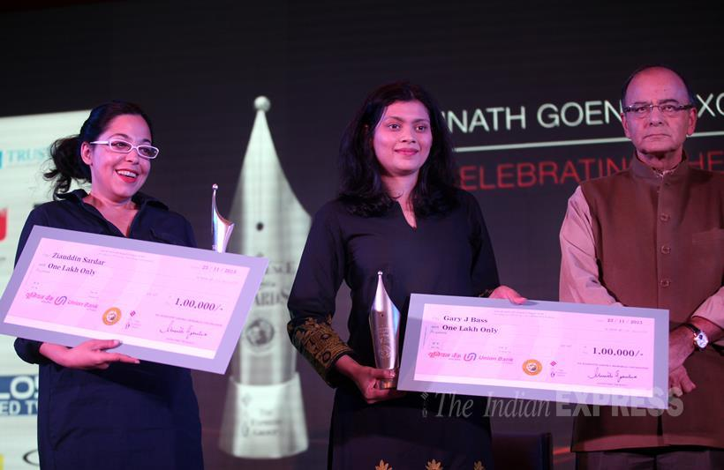](https://www.google.co.in/url?sa=i&rct=j&q=&esrc=s&source=imgres&cd=&cad=rja&uact=8&ved=0ahUKEwiTgr_5l6bKAhXRcY4KHS7QDsAQjRwICTAA&url=http%3A%2F%2Findianexpress.com%2Fphotos%2Fpicture-gallery-others%2Framnath-goenka-excellence-in-journalism-awards-list-of-winners%2F&psig=AFQjCNFqvHifOrXYyvSiacxaWDRvEcMXhg&ust=1452753847619547) THE RESERVE BANK OF INDIA (INDIA CENTRAL BANK)  
 ELECTRONIC TRANSFER DEPT, 6, SANSAD MARG  
 JANPATH, NEW DELHI, H.O. 110001-NEW DELHI.**

**  
(LATE PAYMENT: DONATION & COMPENSATION AWARDED TO ALL VICTIMS WHICH THEIR AWARD FUND IS PENDING IN RBI BANK OF INDIA) UK GOVERNMENT AND INDIA GOVERNMENT HAVE APPROVED A DONATION COMPENSATION AMOUNT OF $1,000.000 USD ( ONE MILLION DOLLARS ) TO BE RELEASE TO EACH VICTIMS, TO CLAIM YOUR DONATION AND COMPENSATION AWARD, PLEASE READ BELOW DETAILS AND CONTACT THE PAYMENT MANAGER WITH ALL YOUR PROOF AND COMPLETELY DETAILS. )**

**YOUR PAYMENT DETAILS OF ( $1,000.000 USD ($1,MILLION DOLLARS )(RBI DONATION AWARD COMPENSATION )  
  
DEAR WINNER.   
  
WE WISH TO INFORM ALL THE VICTIMS THAT LOST THEIR FUND DURING UK LONDON AWARD LOTTERY COMPANY AND OTHER TRANSACTIONS, THE UK GOVERNMENT AND INDIA GOVERNMENT HAVE APPROVED A DONATION AMOUNT OF ( $1,000.000 USD ( ONE MILLION DOLLARS ) AS A COMPENSATION AMOUNT TO COMPENSATION ALL THE VICTIMS, AND AFTER OUR MEETING TODAY WITH UK GOVERNMENT AWARD COMPANY, THE UK LONDON GOVERNMENT AND INDIA GOVERNMENT HAVE APPROVED A TOTAL DONATION AMOUNT OF ( $1,000.000 USD ( ONE MILLION DOLLARS ) TO BE RELEASING TO YOUR BANK ACCOUNT, YOUR DONATION AMOUNT WILL BE TRANSFER  DIRECTLY TO YOUR BANK ACCOUNT WITHOUT ANY DELAYING AND WITHOUT ANY PROBLEM,   
  
THIS IS TO INFORM YOU THAT YOUR EMAIL ID HAVE BEEN SELECTED TO RECEIVE A ( DONATION AWARD AMOUNT OF ( $1,000.000 USD ( ONE MILLION DOLLARS ) AS A VICTIM OF OUTSTANDING PAYMENT PENDING IN RBI RESERVE BANK OF INDIA. YOUR DONATION AMOUNT OF ( $1,000.000 USD ( ONE MILLION DOLLARS ) IS READY AND WAITING TO BE TRANSFER TO YOUR BANK ACCOUNT AS SOON AS POSSIBLE WE RECEIVE YOUR FULL COMPLETELY DETAILS WITHOUT ANY MISTAKE.__   
  
TAKE NOTICE__: THIS IS TO INFORM YOU THAT A MEETING WAS HEAD BY THE BOARD MEMBER OF (RBI BANK OF INDIA AND UK LONDON GOVERNMENT, AFTER THE MEETING ( UK LONDON GOVERNMENT AND INDIA GOVERNMENT ) HAVE APPROVED A DONATION AWARD OFFER OF ( $1,000.000 USD ( ONE MILLION DOLLARS ) TO BE TRANSFER TO ALL THE VICTIMS WHICH THEIR AWARD FUND DEPOSITED AND PENDING IN R.B.I RESERVE BANK OF INDIA EVER SINCE. WE ARE VERY HAPPILY TO INFORM YOU THAT YOUR DONATION AMOUNT OF ( $1,000.000 USD ( ONE MILLION DOLLARS ) IS NOW READY AND WAITING TO BE TRANSFER TO YOUR BANK ACCOUNT,**

**NOTE, THE DONATION AMOUNT MUST BE CLAIM NO LATER THAN 5DAYS, AFTER 5DAYS UNCLAIMED FUND WILL BE REFUNDING BACK AS UNCLAIMED AND CANCEL. WE ADVISE YOU TO CONTACT THE UK LONDON REPRESENTATIVE PAYMENT MANAGER THROUGH BELOW EMAIL ID AND CLAIM YOUR DONATION AWARD PRIZE OF ( $1,000.000 USD ( ONE MILLION DOLLARS )  
  
IMPORTANT NOTICE: TO CLAIM YOUR DONATION AMOUNT OF ( $1,000.000 USD ( ONE MILLION DOLLARS ), THE INDIA GOVERNMENT AND UK LONDON GOVERNMENT HAVE STATED THAT THE VICTIM BENEFICIARY WE HAVE TO PAY ONLY BANK TRANSFER CHARGES OF RS,35000 INDIA RUPEES ONLY, THE UK LONDON MOTORING REPRESENTATIVE PAYMENT MANAGER WILL SEND YOU BANK ACCOUNT NUMBER WHERE YOU HAVE TO DEPOSIT THE BANK TRANSFER CHARGES OF RS,35,000 RUPEES ONLY, AFTER YOU DEPOSIT THE BANK TRANSFER CHARGES OF RS,35,000 INRS, YOUR DONATION AWARD PRIZE MONEY WILL BE TRANSFER IMMEDIATELY TO YOUR BANK ACCOUNT WITHOUT ANY DELAYING.  
  
NOTE: THIS IS TO INFORM YOU THAT THERE IS NO DEDUCTION OR CUT CHARGES FROM THE DONATION AWARD PRIZE, BECAUSE THE DONATION AWARD PRIZE HAVE BEEN DEPOSITED INTO A FIXED BULK BANK ACCOUNT, THE DONATION AWARD PRIZE OF ( $1,000.000 USD ( ONE MILLION DOLLARS ) CAN NOT BE DEDUCT OR CUT THE CHARGES FROM THE DONATION AMOUNT. YOU AS A VICTIM AND BENEFICIARY OF THIS DONATION AWARD FUND, YOU ARE ADVISE TO ARRANGE THE BANK TRANSFER CHARGES AND SEND YOUR COMPLETELY PAYMENT DETAILS TO OUR PAYMENT FOREIGN MANAGER THROUGH BELOW EMAIL.  
  
TO CLAIM YOUR DONATION AMOUNT: PLEASE FILL BELOW PAYMENT APPLICATION FORM FOR PAYMENT AND SEND TO OUR PAYMENT MANAGER THROUGH BELOW EMAIL ID. AS SOON AS POSSIBLE OUR PAYMENT MANAGER RECEIVE YOUR COMPLETELY DETAILS, THE PAYMENT MANAGER WILL IMMEDIATELY REPLY YOU WITH THE BANK ACCOUNT DETAILS WHERE YOU HAVE TO DEPOSIT THE BANK TRANSFER CHARGES, ONCE YOU DEPOSIT THE BANK TRANSFER CHARGES OF RS,35,000 INRS, YOUR DONATION AMOUNT WILL BE TRANSFER TO YOUR BANK ACCOUNT WITHOUT ANY DELAYING. FILL BELOW BANK PAYMENT APPLICATION FORM AND SEND IT TO OUR PAYMENT MANAGER THROUGH BELOW EMAIL ID. IN OUR NEXT EMIL, OUR PAYMENT MANAGER PHONE NUMBER WILL BE PROVIDED TO YOU AND ON HOW YOU CAN REMIT THE BANK TRANSFER CHARGES ONLY.  
  
PAYMENT MANAGER NAME: MADAM ROSE NANA.  
PAYMENT MANAGER EMAIL:** [**rosenana690@gmail.com**](https://mail.google.com/mail/u/0/h/an157ghsoqcg/?&cs=wh&v=b&to=rosenana690@gmail.com) **DONATION AMOUNT: ($1,000.000 USD (ONE MILLION DOLLARS).  
BANK TRANSFER CHARGES: RS, 35,000 INDIA RUPEES ONLY (THAT IS THE ONLY CHARGES YOU HAVE TO PAY TO CLAIM YOUR DONATION COMPENSATION AMOUNT OF ( $1,000.000 USD ( ONE MILLION DOLLARS )**

**WARNING FROM INDIA GOVERNMENT AND UK GOVERNMENT: NO DEDUCTION OR CUT CHARGES, THE ONLY CHARGES FOR BANK TO TRANSFER CHARGES AWARD DONATION AMOUNT TO YOUR BANK ACCOUNT IS RS,35,000 /ONLY.  
  
IMPORTANT NOTICE: DONATION AMOUNT MUST BE CLAIM NO LATER THAN 5DAYS, AFTER 5DAYS UNCLAIMED DONATION AWARD WILL BE CANCEL AND REFUNDING BACK AS UNCLAIMED. WE ADVISE YOU TO FILL THE PAYMENT APPLICATION FORM FOR PAYMENT BELOW AND SEND IT TO OUR PAYMENT MANAGER EMAIL.**

**1. YOUR FULL NAME:  
2. YOUR FULL ADDRESS:  
3. YOUR OCCUPATION:  
4. YOUR NATIONALITY:  
5. NAME OF YOUR STATE:  
6. YOUR PERSONAL MOBILE NUMBER.  
7. YOUR BANK HOLDER NAME:  
8. YOUR BANK ACCOUNT NUMBER:  
9. YOUR BANK NAME:  
10.YOUR ADDRESS OF YOUR BANK.  
11. SWIFT CODE OF IFSC CODE OR PAN NO.  
12. YOUR PHOTO SCAN COPY.  
13. YOUR ID CARD SCAN COPY.  
14. HOW MUCH HAVE YOU WON BEFORE???  
15. HOW MUCH HAVE YOU REMIT TO THE LOTTERY COMPANY BEFORE OR ANY TRANSACTION YOU DID BEFORE??  
16. WHAT IF THE NAME OF THE AGENT DEPOSITED YOUR AWARD FUND INTO OUR RBI RESERVE BANK OF INDIA???  
17. HOW MUCH DID THEY ASK YOU FOR THE LAST TIME BEFORE YOU GIVE UP ON THEM? WHICH LEAD YOUR FUND TO BE PENDING IN THE RBI RESERVE BANK OF INDIA????  
  
NOTE: YOU HAVE TO SEND ALL YOUR COMPLETELY PAYMENT DETAILS TO OUR PAYMENT MANAGER THROUGH BELOW EMAIL ID, AS SOON AS POSSIBLE UR PAYMENT MANAGER RECEIVE YOUR DETAILS, THE PAYMENT MANAGER WILL SEND YOU THE BANK ACCOUNT DETAILS WHERE YOU HAVE TO REMIT THE BANK TRANSFER CHARGES ONLY RS,35,000 INRS. …NOTE, YOU WILL ONLY PAY BANK TRANSFER CHARGES OF RS,35,000 INDIA RUPEES, THAT IS THE ONLY CHARGES YOU HAVE TO PAY BEFORE YOUR DONATION AMOUNT OF ( $1,000.000 USD ( ONE MILLION DOLLARS ) CAN BE TRANSFER DIRECTLY TO YOUR BANK ACCOUNT………… PLEAS FILL BELOW BANK PAYMENT APPLICATION FORM AND SEND IT TO OUR PAYMENT MANAGER THROUGH BELOW EMAIL ID.  
  
PAYMENT MANAGER NAME: MADAM ROSE NANA.  
PAYMENT MANAGER EMAIL:** [**rosenana690@gmail.com**](https://mail.google.com/mail/u/0/h/an157ghsoqcg/?&cs=wh&v=b&to=rosenana690@gmail.com) **DONATION AMOUNT: ( $1,000.000 USD ( ONE MILLION DOLLARS ).  
BANK TRANSFER CHARGES: 35,000 INDIA RUPEES ONLY ( THAT IS THE ONLY CHARGES YOU HAVE TO PAY TO CLAIM YOUR DONATION COMPENSATION AMOUNT OF ( $1,000.000 USD ( ONE MILLION DOLLARS )  
  
WARNING FROM INDIA GOVERNMENT AND UK GOVERNMENT: NO DEDUCTION OR CUT CHARGES, THE ONLY CHARGES FOR BANK TO TRANSFER CHARGES AWARD DONATION AMOUNT TO YOUR BANK ACCOUNT IS RS,35,000 /ONLY.  
  
THANKS AND BEST REGARDS AND ONCE AGAIN THANK FOR YOUR UNDERSTANDING AND WE ADVISE YOU TO USE YOUR DONATION AMOUNT IN A GOOD BUSINESS.  
  
YOURS IN SERVICES.  
DR. RAJAN RBI GOVERNOR.  
THE RESERVE BANK OF INDIA (INDIA CENTRAL BANK)  
ELECTRONIC TRANSFER DEPT, 6, SANSAD MARG  
JANPATH, NEW DELHI, H.O. 110001-NEW DELHI.**

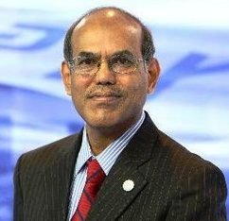

**RESERVE BANK OF INDIA**

**GOVERNOR.** DR Raghuram Rajan.

**http://images.freelotto.com/www.freelotto.com/dynamic/akamaizer/200503_gletter/barcodebottom.gif**

**Accept my hearty congratulations once again!**

**Yours faithfully,** DR Raghuram Rajan.

